|  |  |
| --- | --- |
| NAME | Adwait S Purao |
| UID NO. | 2021300101 |
| Exp. No. | 5 |

**AIM :** To design counters,

a. To design a MOD 6 Asynchronous up/down counter

b. To study IC 7490 – Asynchronous Decade Counter

c. To study IC 74163 as Synchronous MOD 16 Counter

d. To study IC74163 as Synchronous counter for counting 3 to7

e. To study Ring counter and Johnson counter

**HARDWARE:** PCB Board, IC 7490, IC 74163, IC 7420, IC 7404, IC 74194

**THEORY:**

*COUNTER*

An electronic counter is a **sequential logic** circuit which has a clock input signal and a group of output signals that represent an integer "counts" value. Upon each qualified clock edge, the circuit will increment (or decrement, depending on circuit design) the counts. When the counts have reached the end of the counting sequence (maximum counts when incrementing; zero counts when decrementing), the next clock will cause the counts to overflow or underflow and the counting sequence will start over. Internally, counters use flip-flops to represent the current counts and to retain the counts between clocks. Depending on the type of counter, the output may be a direct representation of the counts (a binary number) or it may be encoded.

Counters are broadly divided into two categories:

1. Asynchronous counter

2. Synchronous counter

a. *ASYNCHRONOUS COUNTER:*

Asynchronous counters are those whose output is free from the clock signal. Because the flip flops in asynchronous counters are supplied with different clock signals, there may be delay in producing output.

The required number of logic gates to design asynchronous counters is very the required number of logic gates to design asynchronous counters is very less. So they are simple in design. Another name for Asynchronous counters is “Ripple counters”.

The number of flip flops used in a ripple counter is depends up on the number of states of counter (ex: Mod 4, Mod 2 etc.). The number of output states of counter is called “Modulus” or “MOD” of the counter. The maximum number of states that a counter can have is 2n where n represents the number of flip flops used in counter.

For example, if we have 2 flip flops, the maximum number of outputs of the counter is 4 i.e. 22. So it is called as “MOD-4 counter” or “Modulus 4 counter”.

*DIFFERENT TYPES OF ASYNCHRONOUS COUNTER:*

There are many types of Asynchronous counters available/ used in digital electronics, for e.g.:

2 bit Asynchronous counter

4 bit Asynchronous UP counter

4 bit Asynchronous DOWN counter

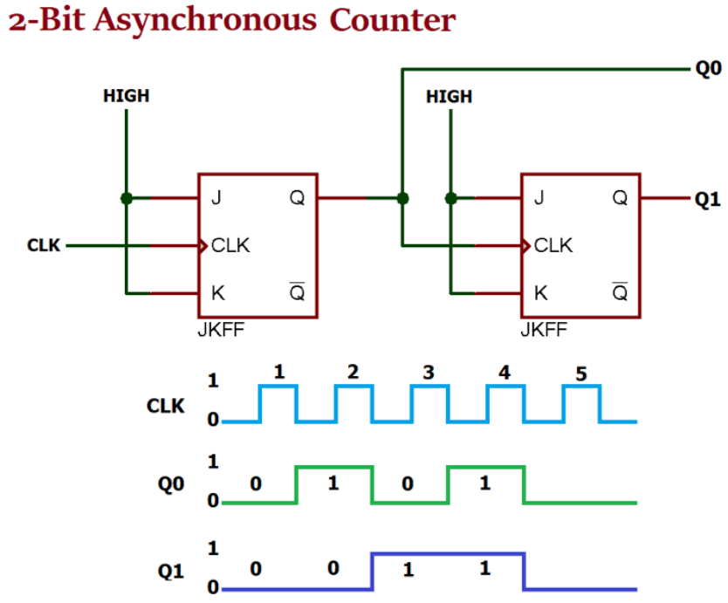

2 Bit Asynchronous counter

*APPLICATION OF ASYNCHRONOUS COUNTER:*

1. Asynchronous counters are used as frequency dividers, as divide by N counters.

2. These are used for low power applications and low noise emission.

3. These are used in designing asynchronous decade counter.

4. Also used in Ring counter and Johnson counter.

5. Asynchronous counters are used in Mod N ripple counters. EX: Mod 3, Mod 4, Mod 8, Mod 14, Mod 10 etc.

*Advantages of Asynchronous Counters*:

* Asynchronous Counters can easily be made from Toggle or D-type flip-flops.
* They are called “Asynchronous Counters” because the clock input of the flip-flops are not all driven by the same clock signal.
* Each output in the chain depends on a change in state from the previous flip-flops output.
* Asynchronous counters are sometimes called ripple counters because the data appears to “ripple” from the output of one flip-flop to the input of the next.
* They can be implemented using “divide-by-n” counter circuits.
* Truncated counters can produce any modulus number count.

*Disadvantages of Asynchronous Counters*:

* An extra “re-synchronizing” output flip-flop may be required.
* To count a truncated sequence not equal to 2n, extra feedback logic is required.
* Counting a large number of bits, propagation delay by successive stages may become undesirably large.
* This delay gives them the nickname of “Propagation Counters”.
* Counting errors occur at high clocking frequencies.
* Synchronous Counters are faster and more reliable as they use the same clock signal for all flip-flops.

*b. SYNCHRONOUS COUNTER:*

Unlike the asynchronous counter, synchronous counter has one global clock which drives each flip flop so output changes in parallel. The one advantage of synchronous counter over asynchronous counter is, it can operate on higher frequency than asynchronous counter as it does not have cumulative delay because of same clock is given to each flip flop.

* **Synchronous Counters** can be made from Toggle or D-type flip-flops.
* Synchronous counters are easier to design than asynchronous counters.
* They are called synchronous counters because the clock input of the flip-flops  
  are all clocked together at the same time with the same clock signal.
* Due to this common clock pulse all output states switch or change simultaneously.
* With all clock inputs wired together there is no inherent propagation delay.
* Synchronous counters are sometimes called parallel counters as the clock is fed in parallel to all flip-flops.
* The inherent memory circuit keeps track of the counters present state.
* The count sequence is controlled using logic gates.
* Overall faster operation may be achieved compared to Asynchronous counters.

*DIFFERENT TYPES OF SYNCHRONOUS COUNTER:*

There are many types of synchronous counter, for e.g.:

* Binary counters.
* 4 bit synchronous UP counter.
* 4 bit synchronous DOWN counter.
* 4 bit synchronous UP / DOWN counter.
* Loadable counters.
* BCD counters.
* Ring counters.
* Johnson counters etc.

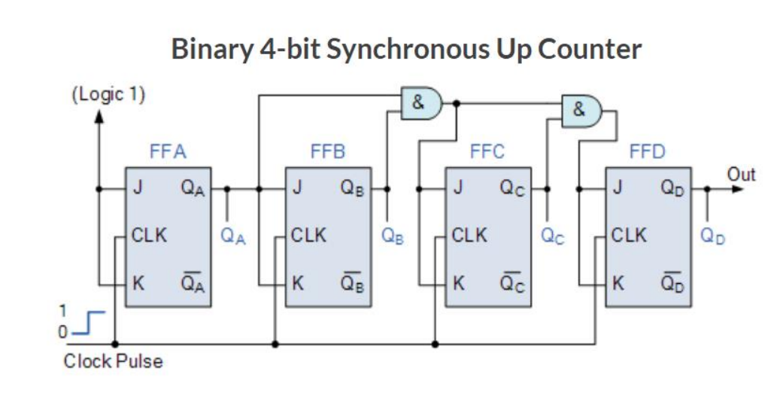

4 Bit Synchronous up counter

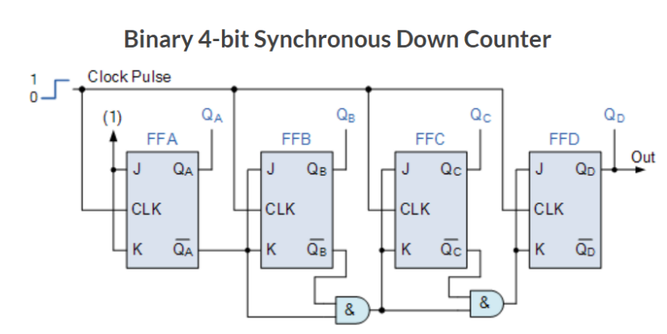

4 Bit Synchronous down counter

APPLICATION OF SYNCHRONOUS COUNTER:

1. Machine Motion control

2. Motor RPM counter

3. Rotary Shaft Encoders

4. Digital clock or pulse generators.

5. Digital Watch and Alarm systems.

The **advantages of the Synchronous counter** is as follows-

1. it’s easier to design than the Asynchronous counter.

It acts simultaneously.

2. No propagation delay associated with it.

3. Count sequence is controlled using logic gates, error chances are lower.

4. Faster operation than the Asynchronous counter.

c. *DECADE COUNTER:*

A good example of a modulo-m counter circuit which uses external combinational circuits to produce a counter with a modulus of 10 is the Decade Counter. Decade (divide-by-10) counters such as the TTL 74LS90, have 10 states in its counting sequence making it suitable for human interfacing where a digital display is required.

The decade counter has four outputs producing a 4-bit binary number and by using external AND gate and OR gates we can detect the occurrence of the 9th counting state to reset the counter back to zero. As with other mod counters, it receives an input clock pulse, one by one, and counts up from 0 to 9 repeatedly.

Once it reaches the count 9 (1001 in binary), the counter goes back to 0000 instead of continuing on to 1010. The basic circuit of a decade counter can be made from JK flip-flops that switch state on the negative trailing-edge of the clock signal as shown.

*CIRCUIT DIAGRAM OF DECADE COUNTER : -*

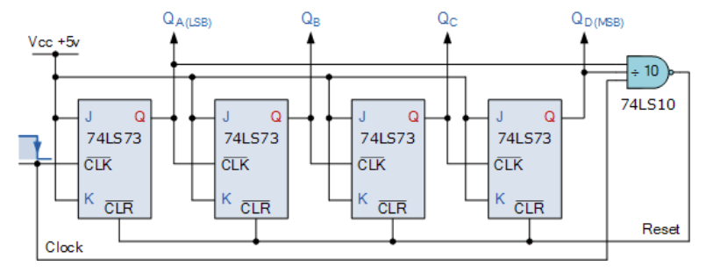

Circuit diagram of decade counter using JK Flip-flop

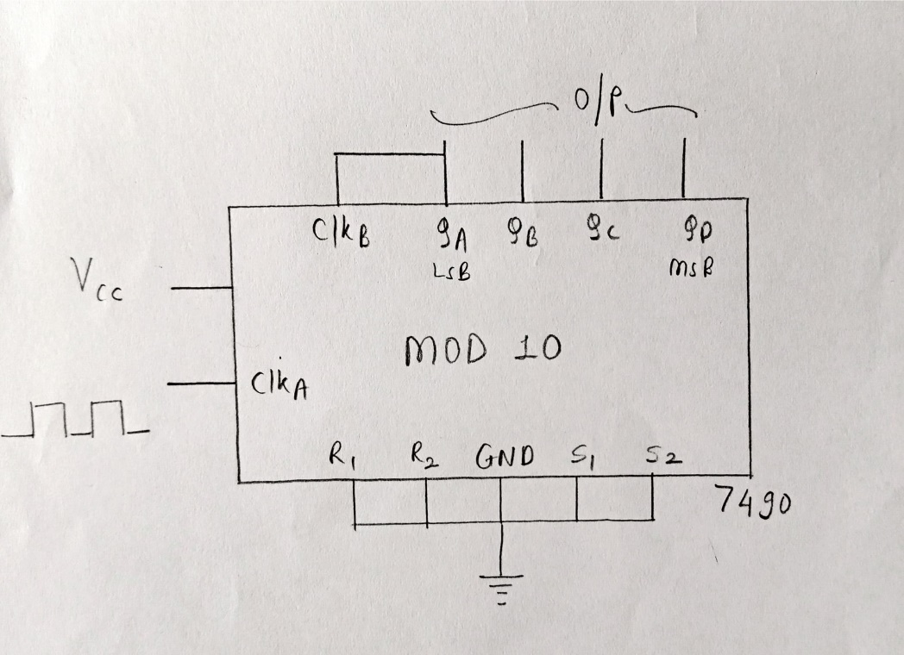

Circuit diagram of mod 10 counter using IC 7490

*TRUTH TABLE OF DECADE COUNTER:-*

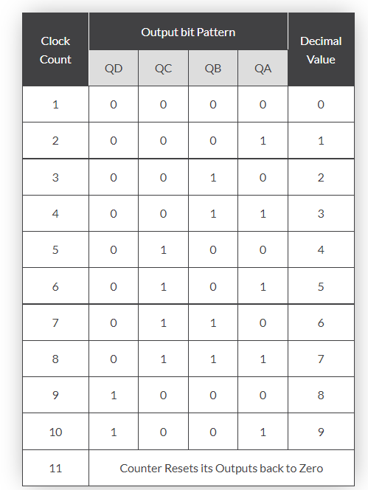

Truth table of decade counter

d. RING COUNTER:

**Definition:**

A ring counter is also known as SISO ([serial in serial out](https://www.elprocus.com/what-is-a-shift-register-different-types-counters-and-applications/)) shift register counter, where the output of the flip flop is connected to the input of the flip flop which acts as a ring counter. The designing of the ring counter can be done by using four [D-Flip Flops](https://www.elprocus.com/types-of-flip-flop-conversions/) with a common clock signal and overriding input can be connected to pre-set and clear.

*CIRCUIT DIAGRAM OF RING COUNTER: -*

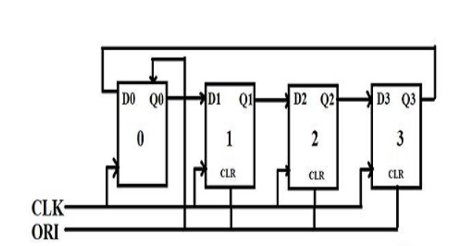

Circuit diagram of RING counter using D Flip-flop

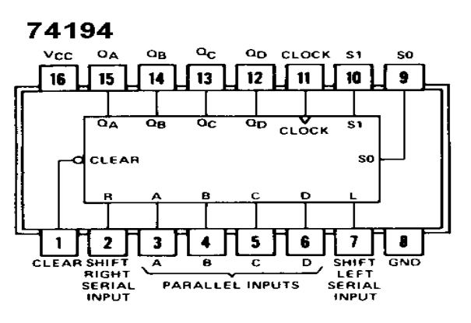

Circuit diagram of ring counter using IC 74194

*TRUTH TABLE OF RING COUNTER:-*

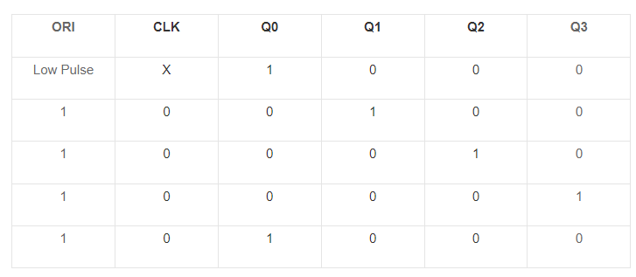

Truth table of RING counter

Advantages of ring counter:

1. It can [encode](https://www.elprocus.com/encoders-and-decoders/) and decode the logics

2. Implementation can be done using [JK](https://www.elprocus.com/digital-electronics-flip-flop-circuit-types-and-applications/) and D flip flops

Disadvantages of ring counter:

1. Out of 15 states, 4 states are used

2. Non-self-starting.

Applications of ring counter:

* [Frequency counter](https://www.elprocus.com/types-of-counters-in-digital-circuits/)
* [ADC](https://www.elprocus.com/analog-to-digital-adc-converter/)
* [Digital clocks](https://www.elprocus.com/digital-alarm-clock-with-8051-microcontroller/)
* Measure timers and rate, etc.

e. JOHNSON COUNTER:

**Definition:**

It is also known as a modified ring [counter](https://www.elprocus.com/counter-type-adc-analog-to-digital-converter/). It is designed with a group of flip-flops, where the inverted output from the last flip-flop is connected to the input of the first flip-flop. Generally, it is implemented by using D flip-flops or JK flip-flops. It is also known as an inverse feedback counter or twisted ring counter. This follows the sequence of bit patterns. When compared to the ring counter, it uses only half of the number of flip-flops. So, the MOD will be 2n, if there are n flip-flops.

*CIRCUIT DIAGRAM OF JOHNSON COUNTER: -*

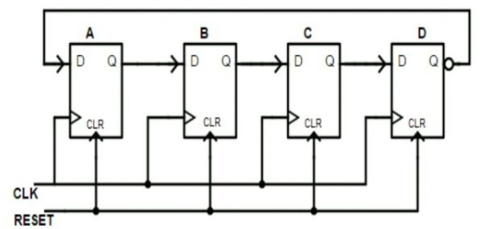

Circuit diagram of JOHNSON counter using D Flip-flop

*TRUTH TABLE OF JOHNSON COUNTER:-*

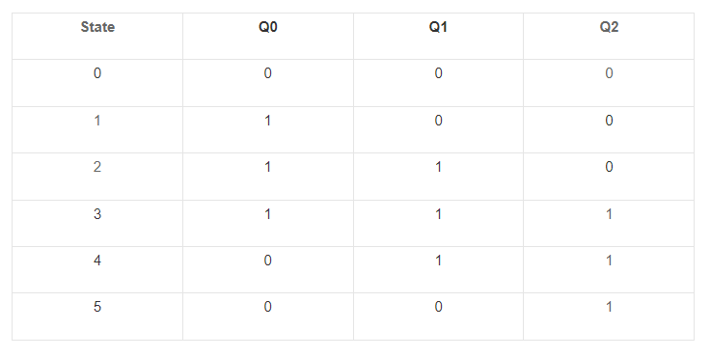

Truth table of JOHNSON counter

#### Advantages of Johnson counter:

* The Johnson counter counts the no. of stages twice equal to the no. of clock pulses given to the [flip-flops](https://www.elprocus.com/types-of-flip-flop-conversions/).
* It counts the events in a continuous closed loop within the circuit.
* It can be designed by using D and JK flip-flops
* It can be used as a self-decoding circuit.

#### Disadvantages of Johnson counter:

* It cannot be used to count the binary [sequence](https://www.elprocus.com/ac-mains-phase-sequence-indicator/)
* It doesn’t utilize all the stages equal to the no. of stages in the counter.
* It needs only half the no. of flip-flops on half the no. of timing [signals](https://www.elprocus.com/generating-pwm-signals-variable-duty-cycle-fpga/)
* It is used in any timing sequence.

#### **Applications of Johnson counter:**

* Johnson counters are used as frequency dividers and pattern recognizers.
* It is used as a synchronous decade [counter](https://en.wikipedia.org/wiki/Counter) and divider circuit
* It can be used to create complicated finite state machines in hardware logic design.
* The 3-bit Johnson counter is used as a 3-phase square wave generator to produce 120 degrees phase shift
* The frequency of the clock signal is divided by varying their feedback.

Difference between Ring counter and Johnson counter:

|  |  |
| --- | --- |
| **Ring Counter** | **Johnson Counter** |
| The output of the last flip-flop is given as input to starting flip flop. | The output of the last flip-flop is complemented and given as input to starting flip flop. |
| Number of states = Number of flip flops used | If ‘n’ number of flip flops are used then ‘2n’ number of states is required. |
| Input [frequency](https://www.elprocus.com/frequency-modulation-and-its-applications/) = n | Input frequency = f |
| Output frequency = f/n | Output frequency = f/2n |
| Total unused states = ( 2n – n) | Total unused states = ( 2n – 2n) |

**PROCEDURE:**

1. Select IC 7490, IC 74163, IC 7420 (4 INPUT NAND GATE), IC 7404(NOT GATE), IC 74194(4 BIT REGISTER) and breadboard.

2. Connect the switches of the breadboard.

3. Now take the required IC and place it on the breadboard.

4. Now connect the inputs of the required IC to their respective logics using wires.

5. Connect the ground and VCC of the required IC to Logic 0 and 1 respectively.

6. Connect the output of the IC to cathode Led.

7. Once all the connections in the circuit are made, switch on the breadboard and observer the led at bottom of the breadboard.

**RESULT & OBSERVATION:**

1. *MOD 10 Asynchronous counter:*

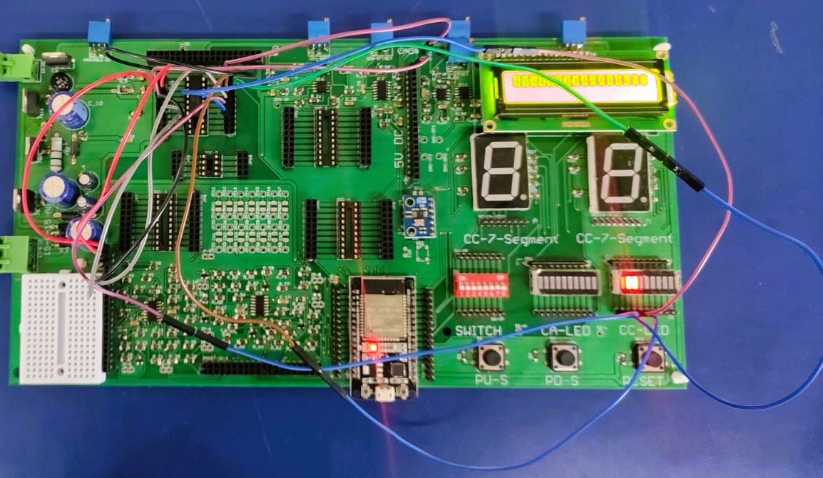

2. *MOD 6 Asynchronous counter:*

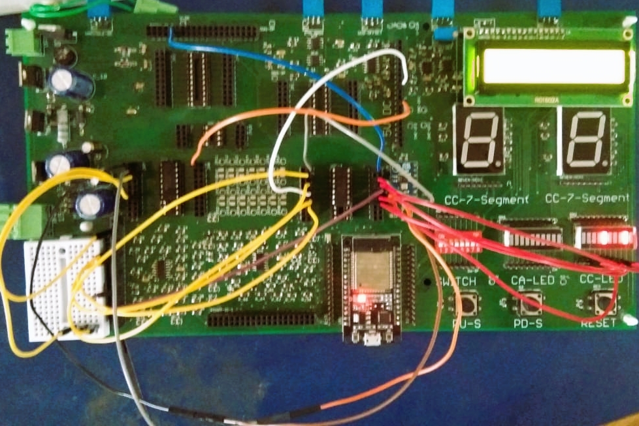

3*. Mod 16 Synchronous counter*

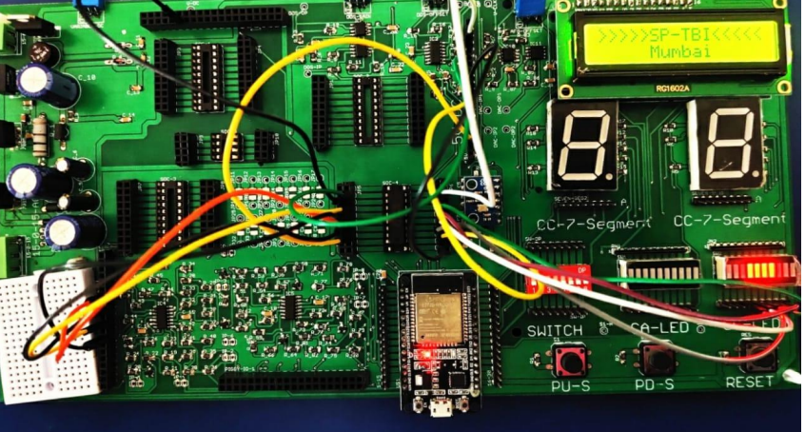

4. *Synchronous counter to count 10 to 1*:

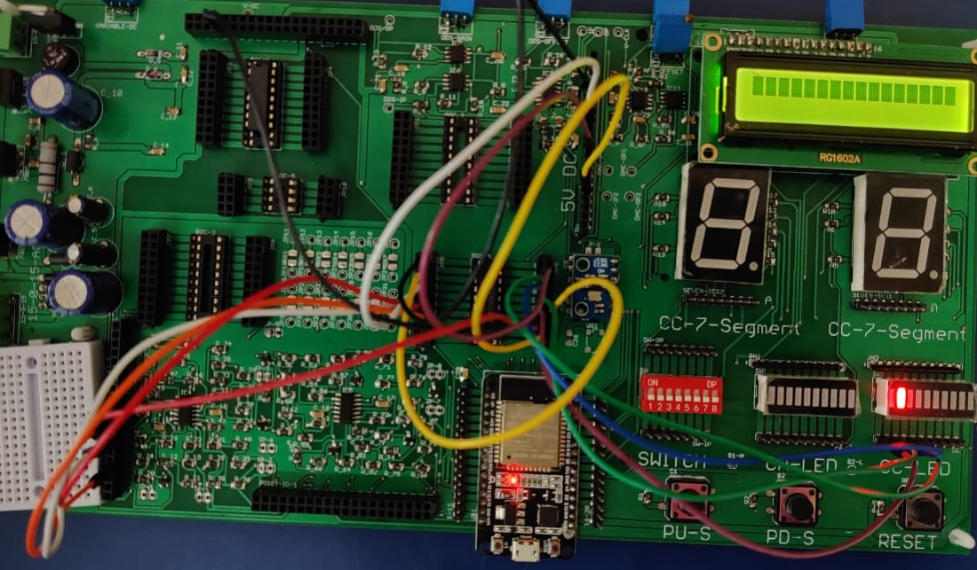

5.MOD 5 counter

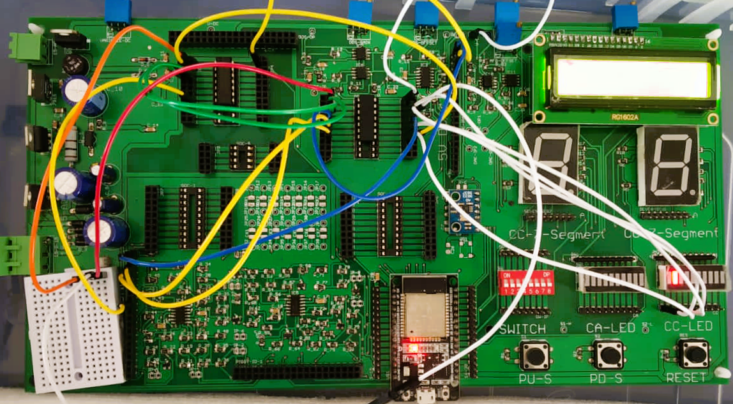

6. *RING counter:*

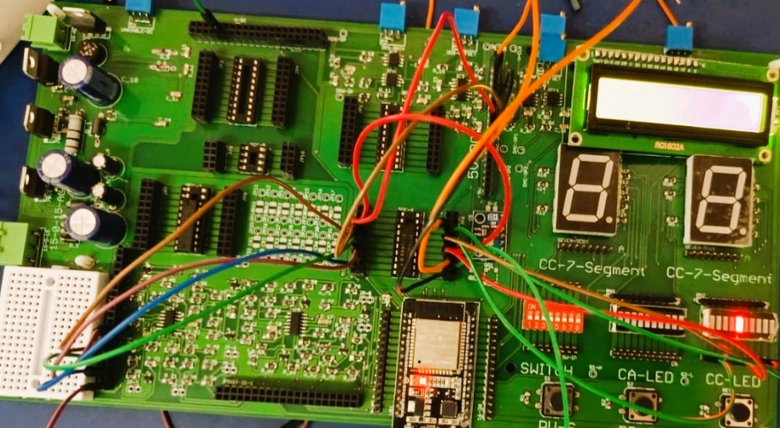

7. *JOHNSON counter*:

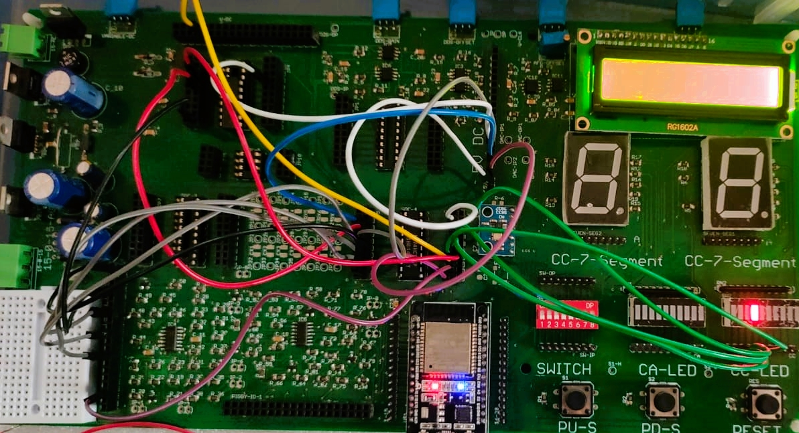

**CONCLUSION:**

